Location Groups and Pages Solution

Exercise 1: Investigation

1. Navigate to the Loss Details screen for an Auto claim. Identify the name of the PCF file that contains the currently visible element. (Choose the best shortcut depending on the information you need - the Info Page (Alt-Shift-I), the Widget Inspector (Alt-Shift-W), or Studio (Alt-Shift-E)).   
     
   What file contains the…
   1. Tab bar (HINT: It starts with "Tab") Tabbar
   2. "Second-level" location group (which includes the side bar) Claim
   3. "Third-level" location group (which renders as menu links) ClaimLossDetailsGroup
   4. Page ClaimLossDetails
   5. Screen ClaimLossDetails
   6. Detail view LossDetailsDV.Auto

Answer the following questions about the PCF file that contains the Claim tab's location group.

1. How many entry points does the location group have?  
     
   One --> Claim(Claim:Claim)
2. What is the name of the file that stores the location group's info bar? What sort of widget is the first (left-most) widget in the info bar? Is this widget always displayed? What about the second widget?  
     
   ClaimInfoBar. Label. Yes, the first widget is always displayed because the visible property is blank. The second widget (another Label) is not always displayed. It is only visible when the claim is in litigation.
3. What is the name of the file that stores the location group's menu actions? What is the name of the first menu item in this file which is stored directly in this file (and not referenced by a Menu Item Set Ref) and which does something when clicked (as opposed to being a non-clickable label)?  
     
   ClaimMenuActions. "Reserve". (The first set of menu items are not stored directly in the ClaimMenuActions file. They are in ClaimNewMenuItemOtherSet and are referenced using a Menu Item Set Ref. The next menu item, "New Transaction", is non-clickable. It has no action attribute. The menu item after that, "Reserve", is the first clickable menu item stored directly in the file.)
4. In the file containing the Claim tab's location group, there is a location ref named "Subrogation". The location ref has no visible condition, and yet it does not display when you view the Ray Newton auto claim. Why?  
     
   The location ref navigates to ClaimSubrogationGroup. This child location group has a canVisit attribute which, in part, requires the claim to have an open subrogation status. Because this claim is not open for subrogation, the condition returns false. If a location's canVisit attribute is false, links to the location are not displayed. To prove this to yourself, go to the Claim Status screen, edit, and change the claim’s Subrogation Status field to “Open.” When you update the claim, you will see the Subrogation menu link appear.

Exercise 2: Configuration

The solution is shown in the screenshots below. (The display keys have not been included.)

First you define the new **Officials** page. Include a panel ref to the **EditableOfficialsLV**, and add toolbars for editing and for iterator buttons.

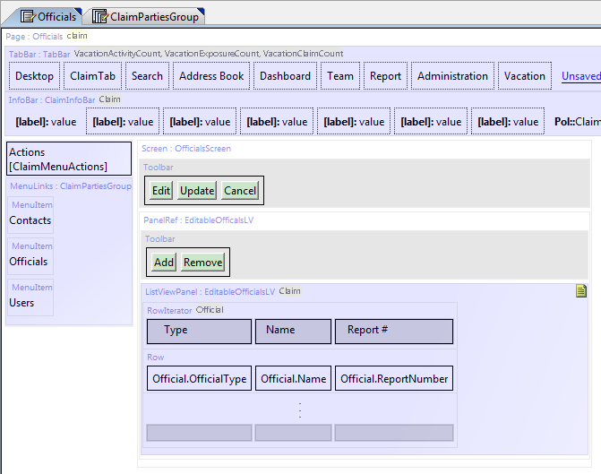Make the page editable, and tell it to start in edit mode.

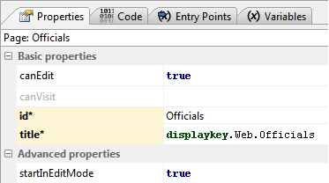

Define an entry point with the claim as a passed in parameter.

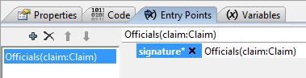

Add the claim parameter as a pcf variable.

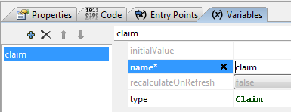

Reference the existing list view.

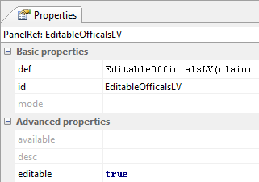

After linking the iterator buttons to the iterator, define the iterator property on the iterator buttons.

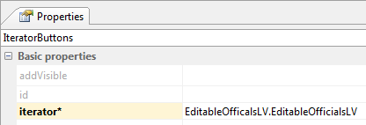

Edit the existing **ClaimPartiesGroup** to have an additional **LocationRef** for officials. Make the **LocationRef** reference the new **Officials** page.

